EXPERIMENT 6
UML DIAGRAMS FOR AN ONLINE FOOD DELIVERY SYSTEM
6 | Design a Class Diagram, Use Case Diagram and Activity Diagram for an Online Food Delivery System using Umbrello UML Modeller. | Umbrello | CO1

Objective
To design UML diagrams (Class, Use Case and Activity) for an Online Food Delivery System using Umbrello, representing system functionality, structure and workflow.

System Description (Short)
The Online Food Delivery System allows customers to browse restaurants, view menus, place food orders, make payments and track delivery. Restaurants manage menus and update order status, while delivery agents accept orders and update delivery progress.

PART 1: CLASS DIAGRAM
Step 1: Open Umbrello
Open the Umbrello UML Modeller application.
Click File → New to create a project.
Step 2: Select Class Diagram
In the left Tree View, right-click Logical View and select New Diagram → Class Diagram.
Name the diagram FoodDelivery_ClassDiagram.
Step 3: Add Classes
Create the following seven classes on the class-diagram canvas:
- Customer
- Restaurant
- Menu
- FoodItem
- Order
- Payment
- DeliveryAgent
Step 4: Add Attributes and Methods
Double-click each class, use the Attributes tab to add attributes and the Operations tab to add methods. Use the following class details:
Class | Attributes | Methods
Customer | customerId, name, address, phone | browseRestaurants(), placeOrder(), makePayment(), trackOrder()
Restaurant | restaurantId, name, location | updateMenu(), acceptOrder()
Menu | menuId | showItems()
FoodItem | itemId, itemName, price | —
Order | orderId, status | updateStatus()
Payment | paymentId, amount, paymentStatus | processPayment()
DeliveryAgent | agentId, name | acceptDelivery(), updateDeliveryStatus()

Step 5: Draw Relationships
Use the Association relationship tool to connect the classes as follows:
- Customer → Order
- Restaurant → Menu
- Menu → FoodItem
- Order → Payment
- Order → DeliveryAgent
Step 6: Save the Class Diagram
Save the Umbrello project using Ctrl + S. Keep the editable project file as FoodDelivery_ClassDiagram.xmi.

PART 1: FINAL CLASS DIAGRAM
The Class Diagram represents the main entities of the food delivery system, their attributes, operations and associations.
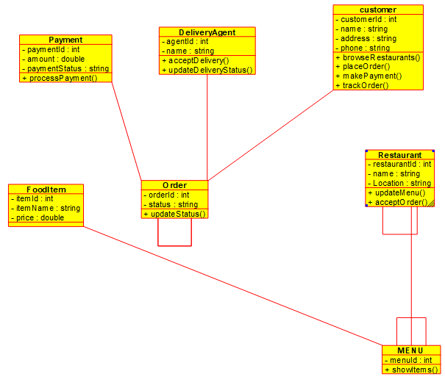
Figure 1. Class Diagram created in Umbrello UML Modeller

PART 2: USE CASE DIAGRAM
Step 1: Create Use Case Diagram
In the left Tree View, right-click Use Case View and select New Use Case Diagram.
Rename the diagram FoodDelivery_UseCaseDiagram.
Step 2: Add Actors
Create the following three actors:
- Customer
- Restaurant
- Delivery Agent
Step 3: Add Use Cases
Customer Use Cases: Browse Restaurants, View Menu, Place Order, Make Payment and Track Delivery.
Restaurant Use Cases: Manage Menu and Update Order Status.
Delivery Agent Use Cases: Accept Delivery and Update Delivery Status.
Step 4: Connect Actors to Use Cases
Use Association lines to connect each actor to the relevant use cases:
- Customer → all five customer use cases.
- Restaurant → Manage Menu and Update Order Status.
- Delivery Agent → Accept Delivery and Update Delivery Status.
Step 5: Save the Use Case Diagram
Save the Umbrello project using Ctrl + S.
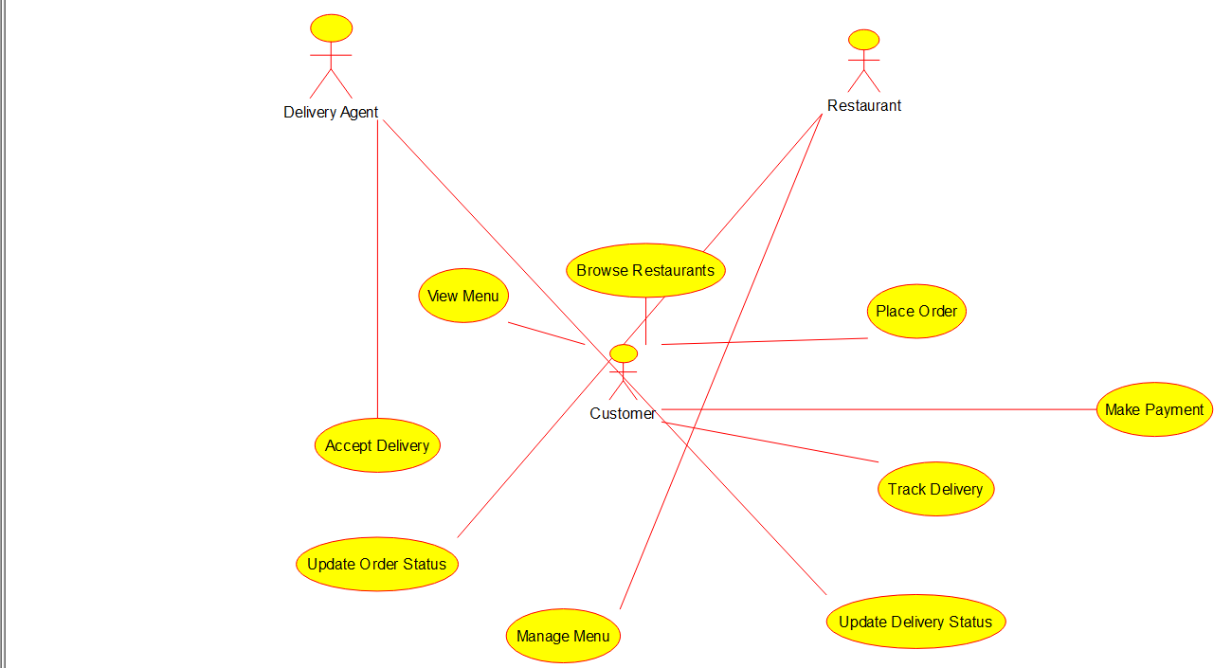
Figure 2. Use Case Diagram showing actors and their interactions with the Online Food Delivery System

PART 3: ACTIVITY DIAGRAM
Step 1: Create Activity Diagram
In the left Tree View, right-click Logical View and select New Diagram → Activity Diagram.
Rename the diagram FoodDelivery_ActivityDiagram.
Step 2: Add Activities in Sequence
Create the Initial Activity (Start), the activity nodes and the Activity Final (Stop) in the following order:
1. Start
2. Browse Restaurants
3. View Menu
4. Select Food
5. Place Order
6. Make Payment
7. Order Confirmed
8. Restaurant Prepares Food
9. Delivery Agent Picks Order
10. Deliver Food
11. Order Completed
12. Stop
Step 3: Connect the Flow
Use Control Flow arrows to connect each activity in the sequence shown above, from Start through Order Completed to Stop.
Step 4: Save the Activity Diagram
Save the Umbrello project using Ctrl + S.
The final Activity Diagram is shown in two adjoining screenshot sections to make the complete vertical workflow easier to read.
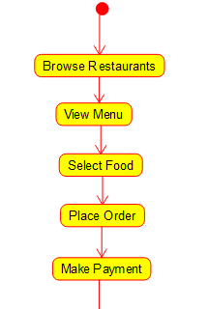  Activity sequence: Start to Make Payment | 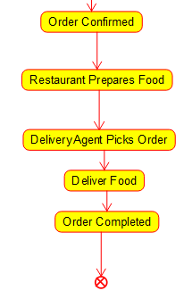  Activity sequence: Order Confirmed to Stop

Result
Thus, the Class Diagram, Use Case Diagram and Activity Diagram for the Online Food Delivery System were successfully designed using Umbrello UML Modeller.

